

Click ‘Buy Tokens’ from the menu, then ‘Buy Tokens Now’ button.

*NB: Would the two menu items ‘Join’ and ‘Buy Tokens’ be confusing?*

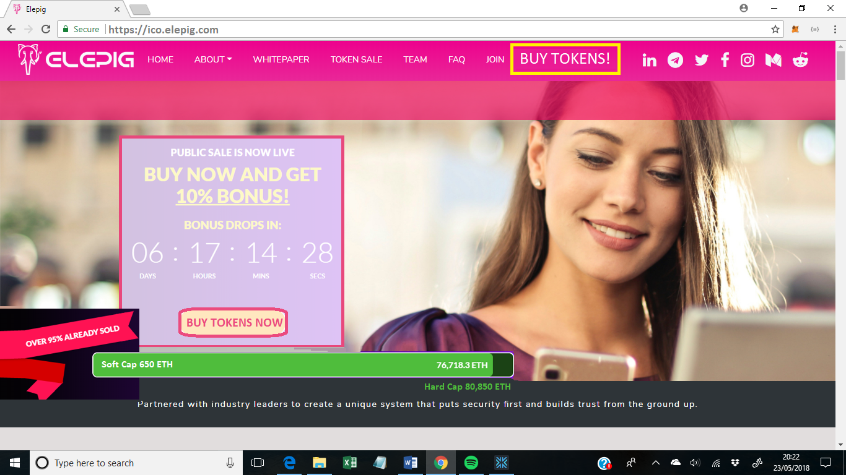

They enter their gmail details and click ‘sign in with Google’ to authenticate. No need for a separate elepig username and password?

They agree with the T&C’s, confirm that they are eligible to participate in a token sale (e.g. not from USA / China), and give consent for us to contact them (they will have to confirm consent via. an email, due to GDPR – and we will have to log this consent somewhere.

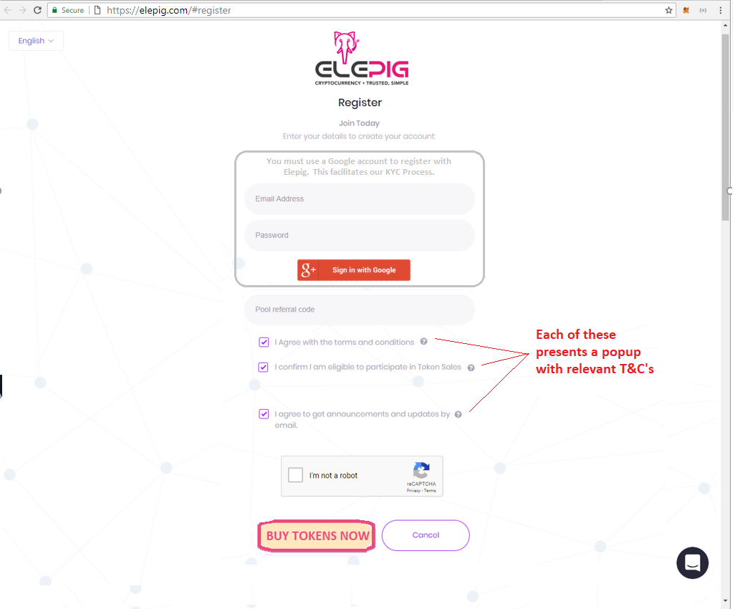

Click ‘Buy Tokens Now’ (repeated wording reinforces the call to action)

NB: Is it possible to auto-populate the Wallet Address if their email matches one already on our whitelist?

They get prompted to give us some basic personal details:

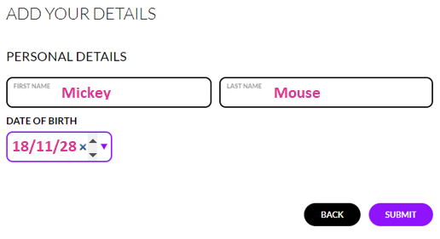

Then enter the ether wallet address they will be paying from. We add this to our whitelist if they pass KYC.

They also specify how much they intend to contribute. Exchange rate and bonuses will be displayed on the next page.

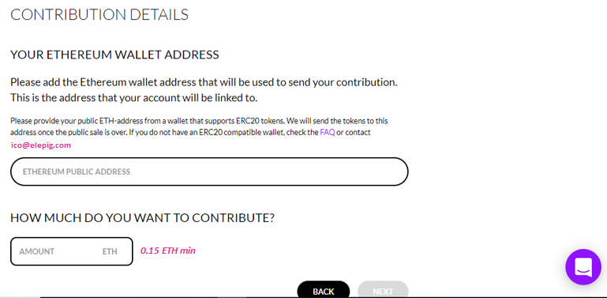

The next page confirms exchange rate and bonus.

Now they are Pending Approval. We will pass their details to a KYC partner, who will email them to complete the process. The final email (if they pass) will contain a link to a page which tells them what Wallet to send their ETH to, and how much to send. Plus ideally a step-by-step guide.

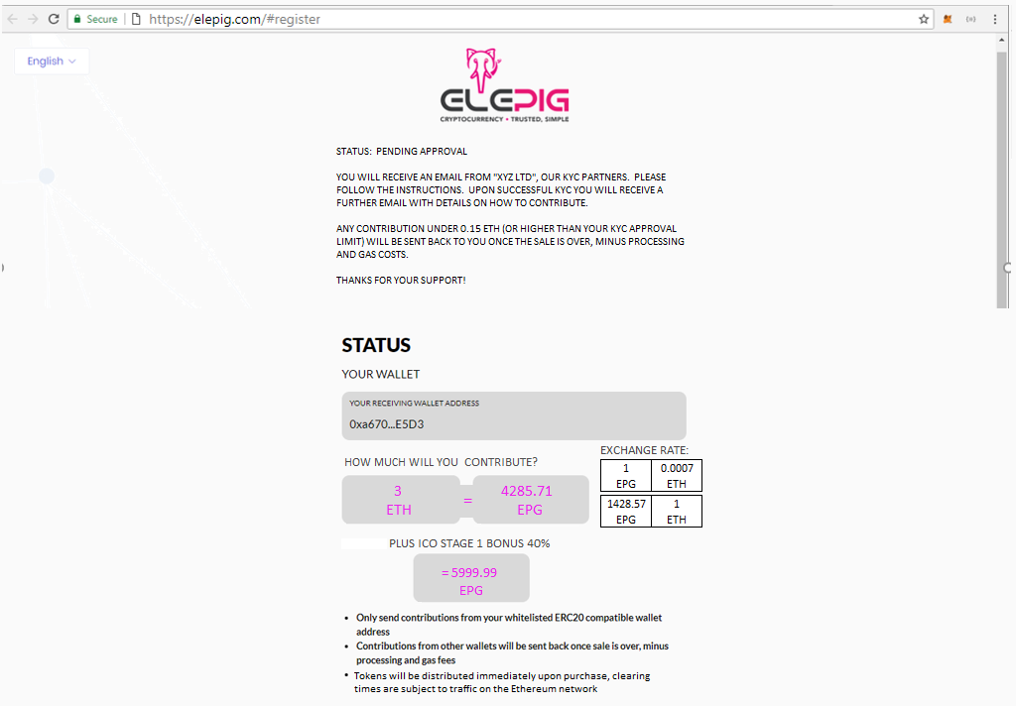

They get presented with a referral link (which is also emailed to them) and share buttons:



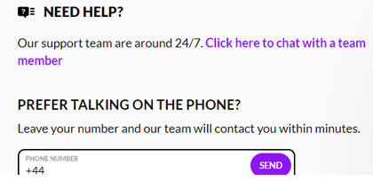

Maybe present them with a summary screen of the progress. Can click on each tab for the various phases and see the progress?

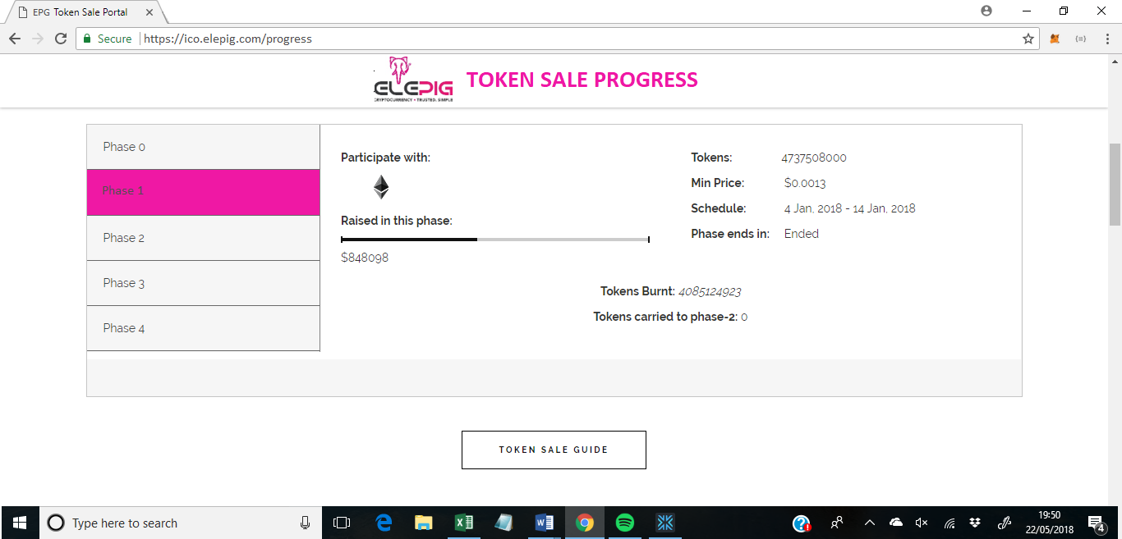

**NEXT STEPS IN THE JOURNEY:**

* Consent confirmation email from elepig
* Referral links email from elepig (if they give consent)
* KYC email from 3rd party
* KYC conducted
* KYC pass? Confirmation email contains link to “how to pay us” page. This contains a calculator for staged conversion rate and gas costs.
* They send us ETH, we issue them EPG
* They don’t get an elepig dashboard, they have to look in their own wallet to see EPG